Optical Brightening Agent 2PL-C
(C.I. 113)
Chemical name | Stilbene bistriazine derivative
Structural formula | 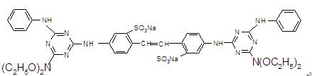
Specification | Appearance: brown liquid  Viscosity: ≤200mpas  PH value: 8.5~10.5  Density: 1.05~1.2g/cm³  Ionic character anionic
Treating process: | 1.Addition pulp: usual dosage : 0.05~1.5% based on the weight of bone dry cellulose  2. Addition via size press: combined with starch, CMC, PVA and other products designed for surface sizing. Usual dosage: 0.5~3g/l  For actual application, the process should be adjusted according to correspondent sample-test.
Property: | - Convenient in application, easily soluble, diluted with water.  2.Good resistance to alkali, perborate
Use: | Mainly be used in size press, pigment coating mixtures.
Package: | 200kg or 1000kg plastic drum or for the special demand.
Note: It needs to be declared that the above data is based on our present knowledge and experience; owing to too many affecting factors, these data cannot be free from their check and test when processing and using the product.

